**Week-2: Show Started Visualizations**

**Group-2**

Devaki B, Keerthi A, Sri Lasya G, Harsha Priya C, Sanjeev Kumar B

Saint Louis University

IS-5960 – Master Research Project

Maria Weber

August 31, 2025

**Data Preparation & Visualization (MRP Project)**

As part of the **MRP (Major Research Project)** preparation, We created structured datasets representing multiple branches of Saint Louis University (SLU), such as **Computer Science, Artificial Intelligence, and Information Technology, and etc**. Each branch dataset contains **100 synthetic records** designed to simulate student and alumni information. The datasets were initially prepared in Excel, later converted to **CSV format**, uploaded into **MySQL Server** through Workbench, and then connected to **Tableau Desktop** for visualization.

This workflow demonstrates a **complete data pipeline** — from raw data creation to database integration and visualization — and serves as a foundation for future analytics and dashboard development.

**Action Points & Steps**

**1. Data Creation**

* Prepared **9 branch-specific datasets** (CS, AI, IT, etc.) with **100 records each**.
* Data attributes included: student name, branch, graduation year, company, location, employment status, technology stack, etc.
* Ensured variety and consistency across branches to simulate real-world alumni/student data.

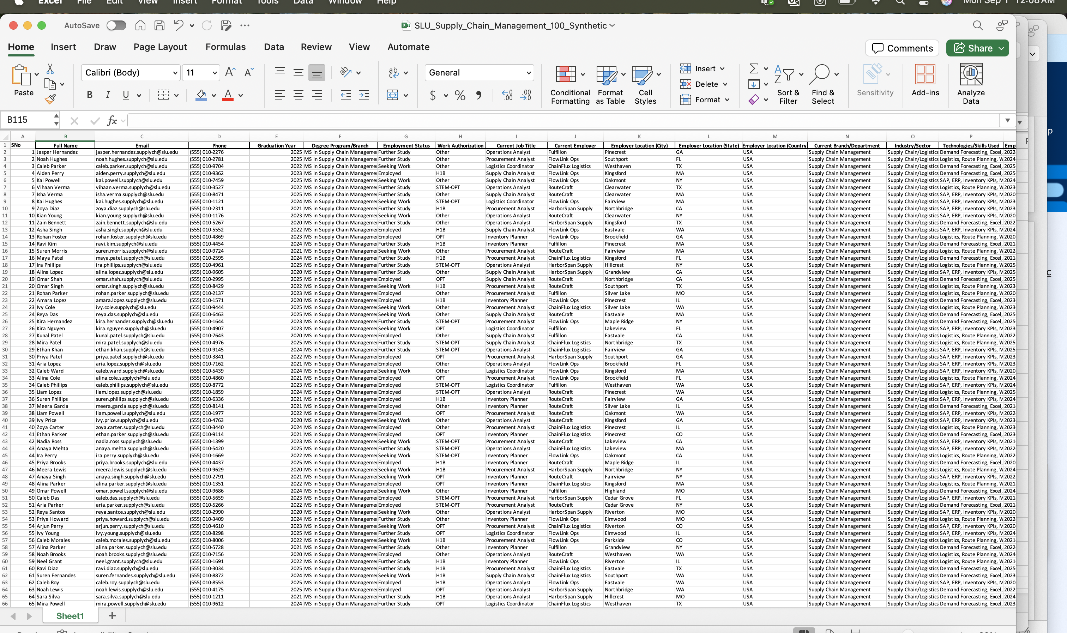

**2. File Preparation**

* Saved each dataset in **Excel format (.xlsx)** for initial review.
* Converted Excel files to **CSV (.csv)** format for compatibility with MySQL and Tableau.
* Verified data formatting (no null headers, proper delimiters).

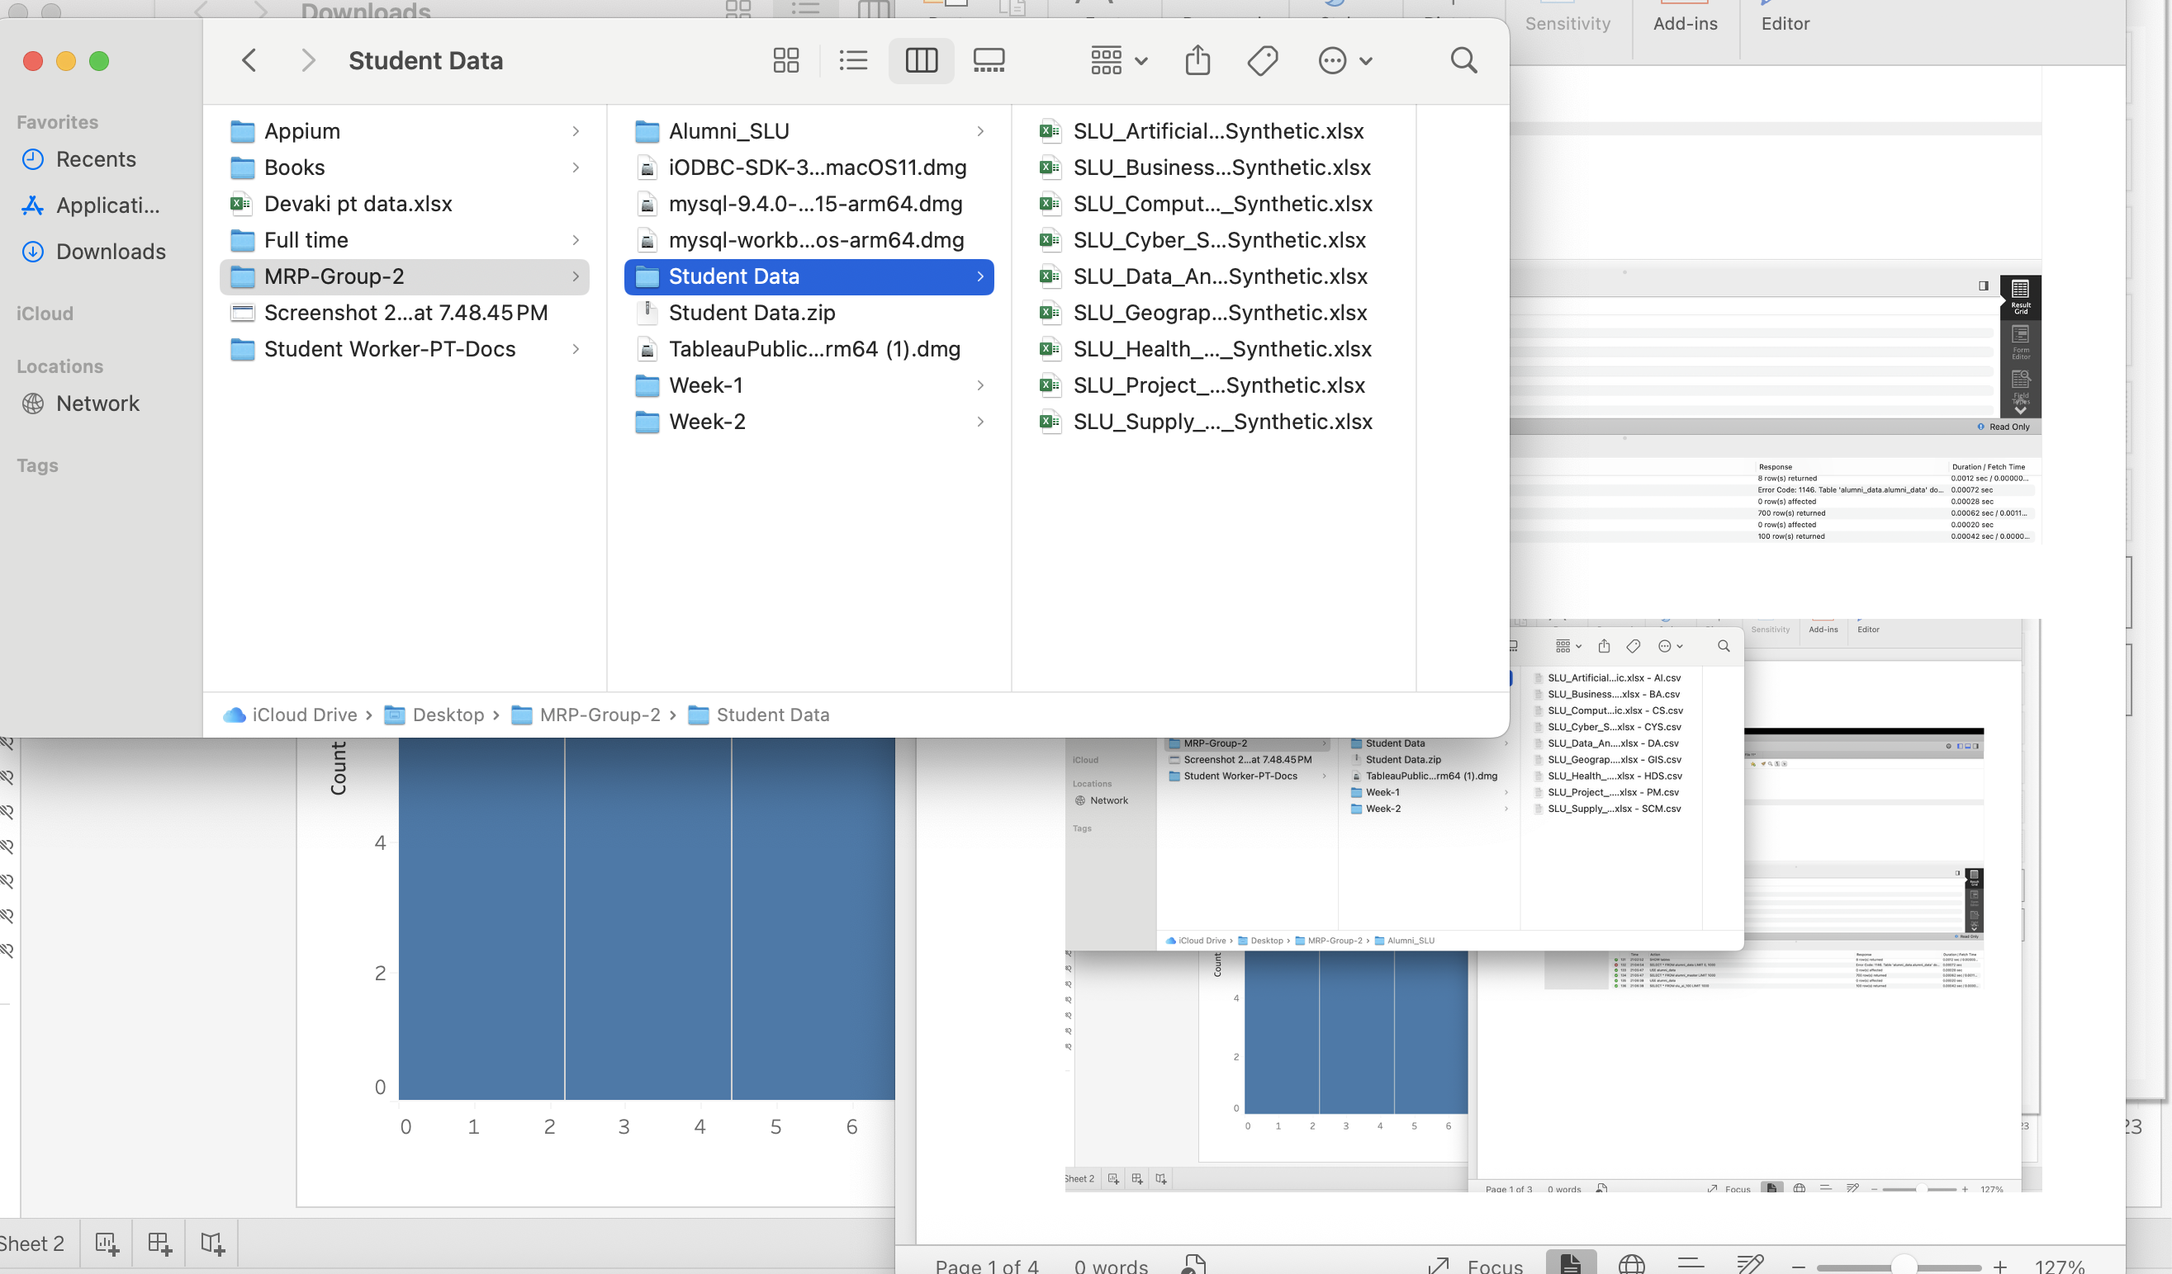

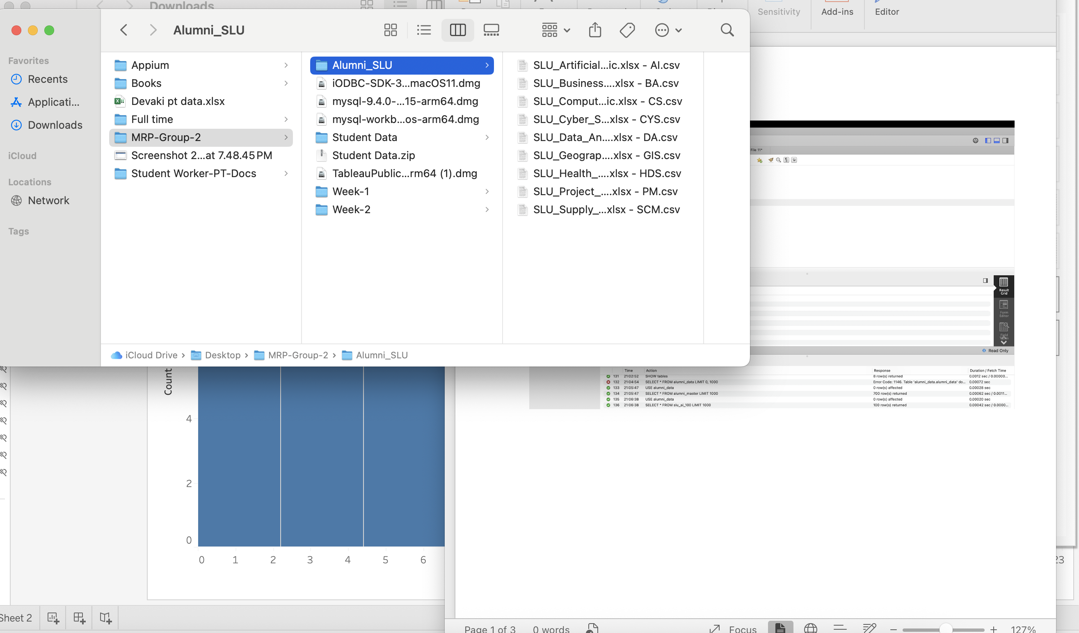

**3. Database Upload via MySQL Workbench**

* Created a database schema in **MySQL** (e.g., alumni_data).
* Imported CSV files into MySQL Workbench using the **Table Data Import Wizard**.
* Verified successful table creation and data insertion by running basic SQL queries (e.g., SELECT * FROM branch_table LIMIT 10;).
* Ensured all 9 datasets were stored as separate tables in the database.

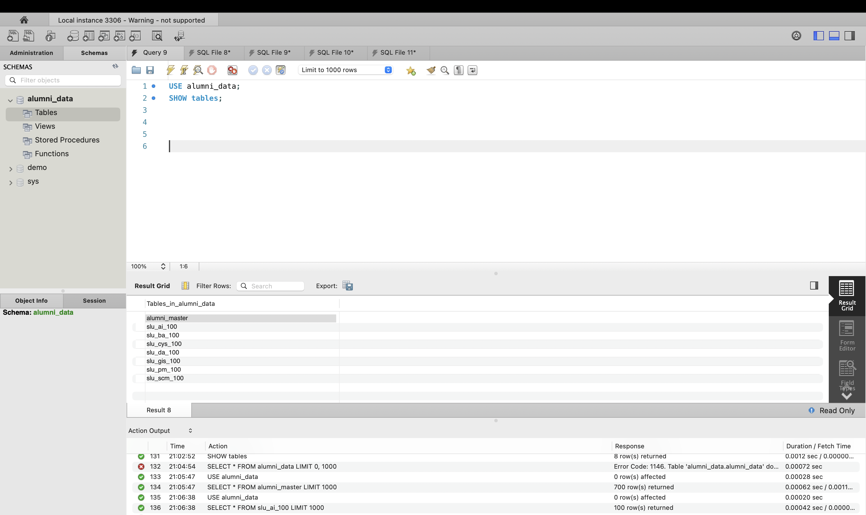

**4. Connecting Tableau with Data**

* Connected **Tableau Desktop** to MySQL Server using database credentials.
* Imported tables directly from **MySQL** into Tableau.
* Additionally, uploaded the same CSV and Excel files directly into Tableau for comparison.
* Cross-checked data consistency between Workbench and Tableau imports.

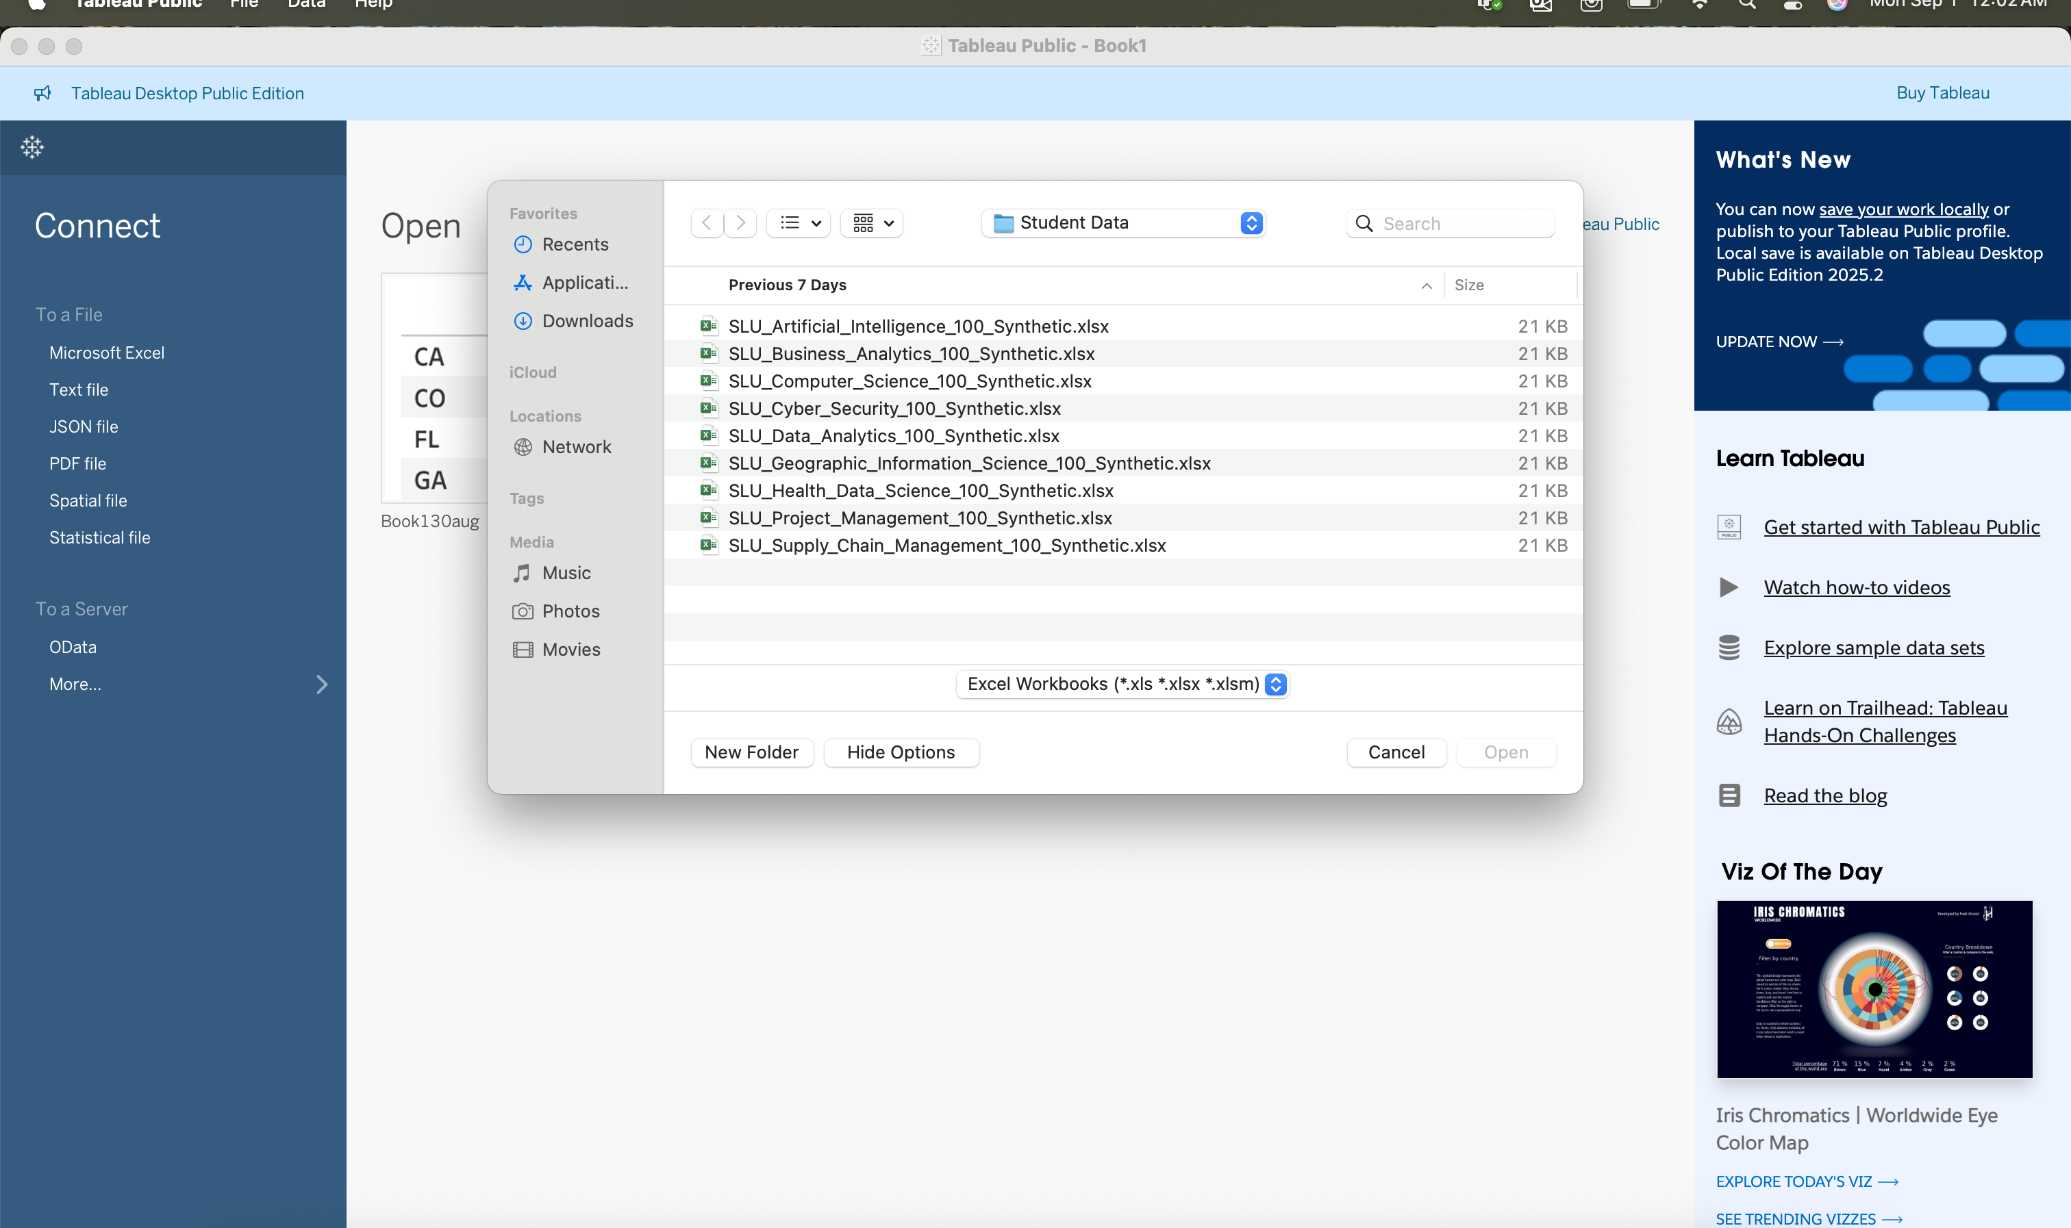

**5. Data Cleaning & Preparation in Tableau**

* Used **Tableau Prep features** (if applicable) to clean and join data.
* Created relationships between branch datasets for unified analysis.
* Verified field types (numeric, string, date).

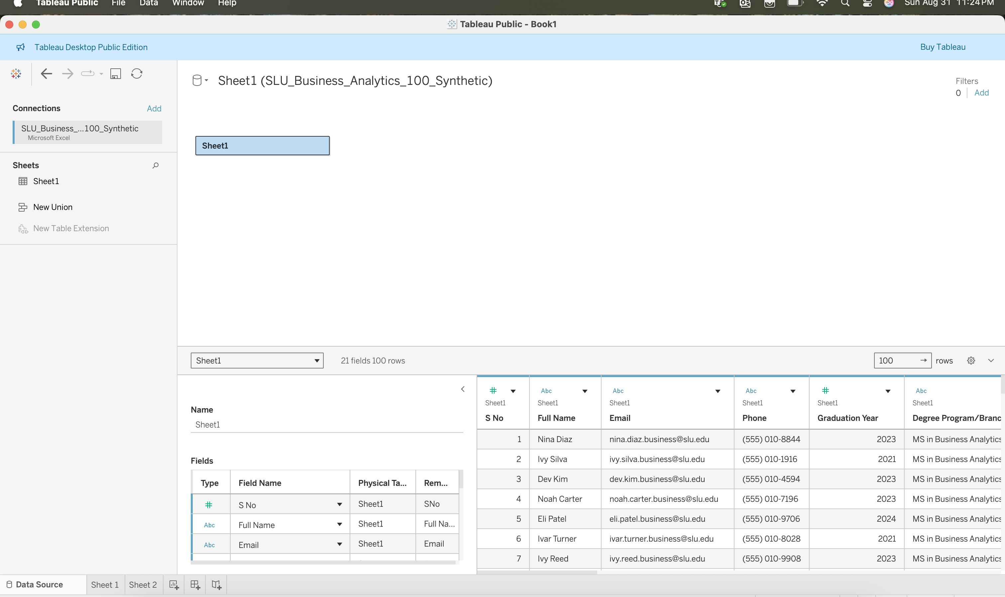

**6. Visualization in Tableau**

* Designed preliminary dashboards showing

Used charts, filters, and calculated fields for interactive insights.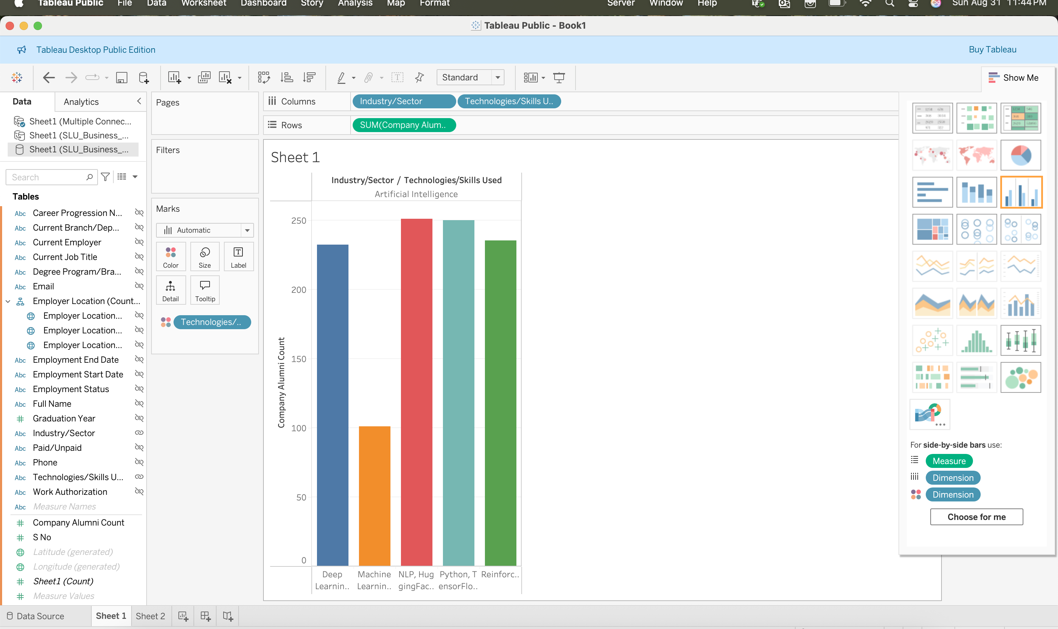This workflow establishes the **baseline data pipeline** for the MRP project:

1. Data generation (Excel → CSV)
2. Database integration (MySQL Workbench)
3. Visualization & analytics (Tableau Desktop)

With this setup, the project team can now proceed to advanced analytics, predictive models, and dashboard storytelling.

